**Sample drawing**

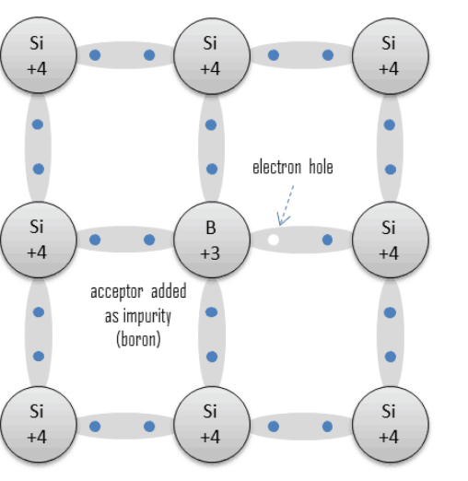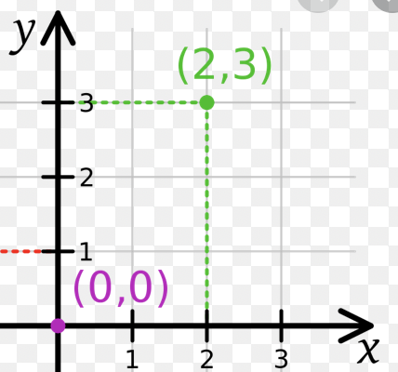

|  |  |  |  |
| --- | --- | --- | --- |
|  | # | **Desired behaviors** | Status |
| No reaction/ 1 charge | 1 | Conduction-band e: translational movement, exiting the semiconductor at one end & entering at the other | In progress |
| 2 | Valence-band e: might jump into valance-band hole if it is chosen | In progress |
| 3 | Valence-band hole: disappear when a Valence-band e jump into its place, & reappear in the e’s old position | In progress |
| Reaction of charges: | 4 | Valence-band e ---> Valence-band hole + Condution-band e (under heat) (explosion) | Not started |
|  | 5 | Valence-band hole + Condution-band e ---> Valence-band e (when a hole and a free e happen to meet) (spiral transition) | Not started |

**TO-DO:**

1. Visual representations
2. A timeline with trigger events & event handle functions etc.(already in the works with the invokemove() function)

Note: there are 2 Types of events:

User input is updated

Desired behaviors -- aka, the natural progression of the semiconductor in time //maybe event isn’t the right word here lol

1. Work on implementing the not started behaviors //or ignore them

**Classes**

0. Settings:

* crystalLength
* crystalWidth
* voltage
* externalField //might not be implemented
* Temperature
* Scalar (to scale speed of conduction band electron according to force fied) //will come up with a less vague variable name

1. Crystal:

* ArrayList<Atom> atoms;

1. (abstract) Atom:

* indexX (value in range(1, Settings.crystalLength))
* indexY (value in range (1, Settings.crystalWidth))
* ValenceBandCharge valenceChargeUp
* ValenceBandCharge valenceChargeRight
* ValenceBandCharge valenceChargeDown
* ValenceBandCharge valenceChargeLeft
* getNearbyAtomsUp() returns Atom:
* getNearbyAtomsRight() returns Atom: //handle edge cases
* getNearbyAtomsDown() returns Atom:
* getNearbyAtomsLeft() returns Atom:
* getValenceChargeUp() returns ValenceBandCharge
* getValenceChargeRight() returns ValenceBandCharge
* getValenceChargeDown() returns ValenceBandCharge
* getValenceChargeLeft() returns ValenceBandCharge
* invokeMove()
* exchangeHoleWithValenceElectron(){

// get ArrayList of valence charges

// if there is a hole(hole){

// identify the position of the hole (ie. up/down/right/left)

// get list of the 4 nearest e to the hole by{

// get list of 3 other electrons in the same atom

// get the electron of the adjacent atom which is in the same bond{

// eg. case ¼: hole is up:

// this.getNearbyAtomsUp().getValenceChargeDown()

// }

// }

// }

// choose the electron with the smallest angle…(e)

// update the references to the exchanged valence charge of two atoms, might need a seperate method

// call hole.move() & e.move

* ConductionBandElectron freeElectron//does the free electron belong to this atom/ any atoms?
* moveInCurrent(){
* //get ArrayList of conducting charges
* // if there is a free e(e){
  + - getListAdjacentAtoms
    - Case1: |V| > 0

//chose atom using min angle

* + - Case2: V = 0
    - // chosse atom randomly
    - Update ConductionBandElectron of 2 atom

//call move() of itself: move(newCoordinate = current coordinate + v)

* //
* }

2a. SiliconAtom extends Atom:

2b. PhosphorousAtom extends Atom:

2c. AluminumAtom extends Atom:

1. (abstract) Charge:

* (abstract) invokemove()
* (abstract) move(newCoordinate)
* checkContainer(Atom)
* checkAdjacentInvoke(Atom)

3a. (abstract) ValenceBandCharge extends Charge

* Bond bond
* getJuxtapositionwithAtom() returns left, right, up, or down using this.bond.getAtom(this).getValenceBandCharges() and then compare the charge with each of the charges returned.

3a1.ValenceBandElectron extends ValenceBandCharge

@Override

* invokemove() //nothing

@Override

* move(newCoordinate) //move in an arc orbit from the current position to newCoordinate

3a2.ValenceBandHole extends ValenceBandCharge

@Override

* invokemove(): // get list of 4 nearby ValenceBandElectron using getNearbyElectron()

// choose the e that is most aligned with force field

//update the bonds involved

Method 1: bind the content of the Bond class with its visual representation: how to bind the content of the Bond class with its visual representation without making the transition immediately (the goal is to stretch the transition gradually over time, not jump right after the calculation)

Method 2: no binding, the content will be updated immediately, but the visual representation will only change in the event a triggerfunction() is called

// call move() of the chosen electron: move(newCoordinate = coordinate of this)

// call the move() of itself: move(newCoordinate = chosen e’s old coordinate)

# (if hole is visible, may need to have the calls to move() run simultaneously, perhaps using threads?)

@Override

* move(newCoordinate): // nothing/fade-out transition at start, then fade-in at end at newCoordinate
* getNearbyElectron() returns ArrayList<ValenceBandElectron>:

First, get nearby electron from the same bond: this.bond.getOtherCharge()

Second, get nearby electrons from from different bonds, but in adjacent atoms:

* Get list of Adjacent Atoms by this.bond.getContainerAtom(this).getNearbyAtoms()
* For each atoms in list, iterate

3b. ConductionBandElectron extends Charge

@Override

* move(newCoordinate):
  + //calculate v = scalar * forcefield
  + //move in an straight-line orbit from the current position to newCoordinate

1. Controls:

4a. Start // button, to start and stop simulation

4b. Voltage // input or slider, to change voltage value

4c. ExternalField // input or slider, to change external field

4d. Temperature // input or slider, to change external temperature

4e. Zoom // button or slider, to change view

1. Information

5a. (static) Notes // to note presentations of figures in simulation

5b. Graph // draw graph, maybe have to use java.swing

5b. (static) Circuit // equivalent circuit

5c. Energy bands: components

1. Draw

drawElectron();

drawHole();

drawRecombination();

drawBackground();

drawGraph();